**IPCTECH Motherboard User's Manual**

**QY-MB-H81-ATX**



**1.Models and Attentions**

**ATX Mother Board**

**1.1 Models**

**This manual is applied to following models:**

|  |  |  |  |  |  |  |  |  |  |
| --- | --- | --- | --- | --- | --- | --- | --- | --- | --- |
| **Chipset** | **COM** | **LAN** | **USB** | **PCIE** | **PCI** | **DVI-D** | **VGA** | **Mini-PCIE** | **SATA** |
| **H81** | **6** | **2** | **10** | **1*16X**  **1*4X**  **1*1X** | **4** | **1** | **1** | **1** | **3** |

**1.2 Attentions**

**1. Notes under a table or figure indicate the difference of models, or alternative definition of specific pin of the header (jumper/connector).**

**2. How to identify the first pin of a header or jumper**

**Usually, there is a thick line or a triangle near the header’s or jumper’s pin 1.**

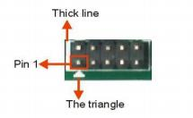

**Square pad, which you can find on the back of the motherboard, is usually used for pin 1.**





**ATX Mother Board**

**2.Specification**

|  |  |
| --- | --- |
| **Model** | **QY-MB-H81-ATX** |
| **CPU** | **Support Intel Pentium / Celeron / 4th Generation Core i3/i5/i7 CPU, LGA 1150** |
| **Chipset** | **Intel H81 [1], TDP 4.1W** |
| **Dispaly** | **1*VGA**  **1*DVI-I Port (Only support DVI-D Signal)** |
| **Memory** | **Support DDR3-1333/1600 MHz, 2*DIMM Slot, up to 16GB 【2】** |
| **Storage** | **1*SATA 3.0+2*SATA 2.0** |
| **Ethernet** | **2*Intel I210 GBE LAN Chip (10 / 100 / 1000 Mbps,RJ-45)** |
| **Audio** | **Reltek ALC897 5.1 Channel HDA Codec,**  **Support MIC / Line-out Ports** |
| **Expansion Slots** | **1*PCIE 16X Slot**  **1*PCIE 4X Slot [4]**  **1*PCIE 1X Slot**  **4*PCI Slot**  **1*Mini-PCIE Slot (WIFI+4G, with 1*Full-Size SIM Card Slot** |
| **COM** | **5*RS-232+1*RS-232 / 485 [3]** |
| **USB** | **2*USB 3.0 (Type-A, Rear I/O)**  **2*USB 2.0 (Type-A, Rear I/O)**  **6*USB 2.0 (Header, Internal)** |



**ATX Mother Board**

|  |  |
| --- | --- |
| **Other Ports** | **8 * GPIO**  **1 * Audio Connector + 1 * Front Audio**  **1 * Mini PCI-E [5]**  **1 * LPT Header**  **1 * SIM Connector**  **1 * PS/2 Connector + 1 * PS/2 Pin Header [6]**  **2 * ATX Power Input Connector** |
| **System** | **Windwos 7, Linux** |
| **Temperature** | **Storage: -20~75℃**  **Operating: 0~60℃** |
| **BIOS** | **AMI UEFI BIOS (Support Watchdog Timer)** |
| **Size** | **305mm * 220mm** |

**Notes:**

**Chipset can be customized into Intel B85.**

**[2]: Due to the restriction of Windows 32bit OS, when applied more than 4G memory, 32bit OS may**

**detect less than actual size.**

**[3]: Signal of J_COM3 is RS232 by default. It also can be RS485 via Jumper JCOM3_485.**

**[4]: This PCI-E X4 slot can only support PCI-E X1 device for it just have PCI-E X1 signal.**

**[5]: Mini PCI-E1 slot supports mSATA (SATA 3.0) by default at the cost of invalidating SATA1.It can also support 3G/WIFI if specialized. When it supports 3G, one of the USB ports of F_USB3 will be invalid.**

**[6]: The PS/2 Connector and the PS/2 Pin Header share the same signal; they can’t be accessed**

**simultaneously.**



**ATX Mother Board**

**3.Functional Block Diagram**

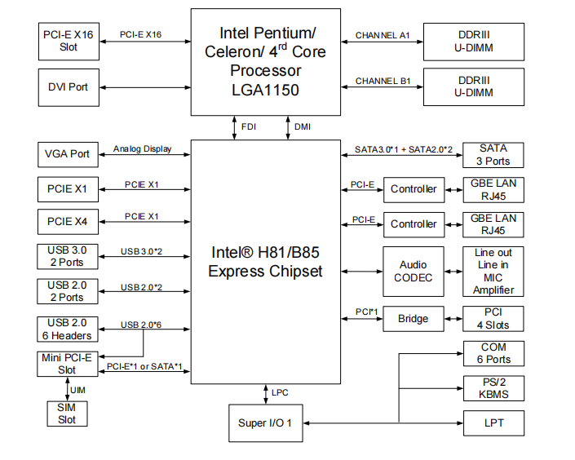



**ATX Mother Board**

**4. Jumpers / Headers and Connectors**

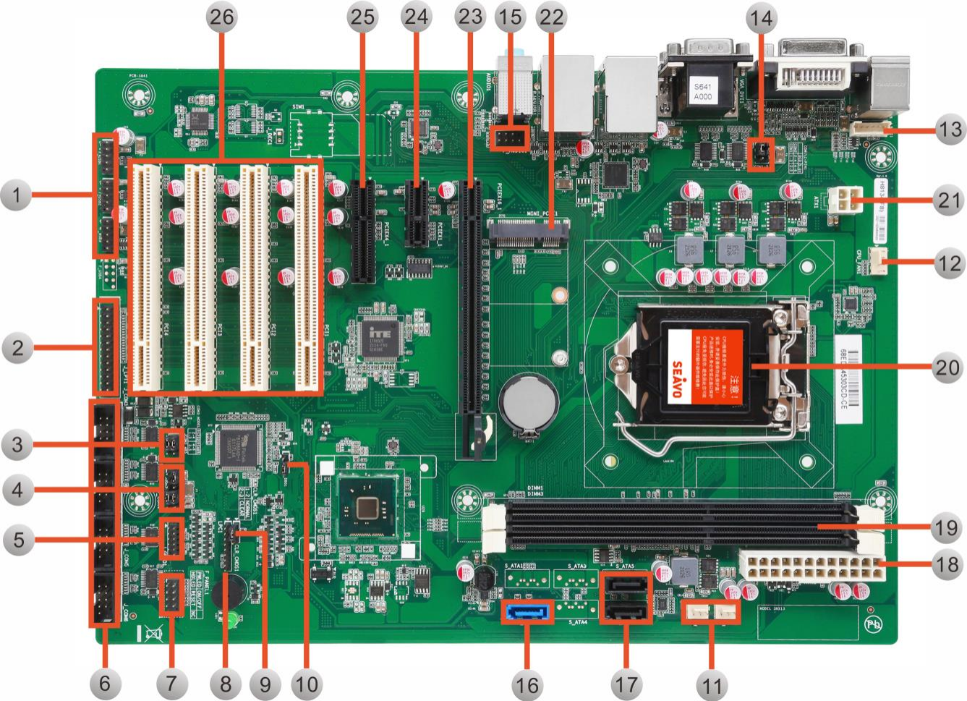

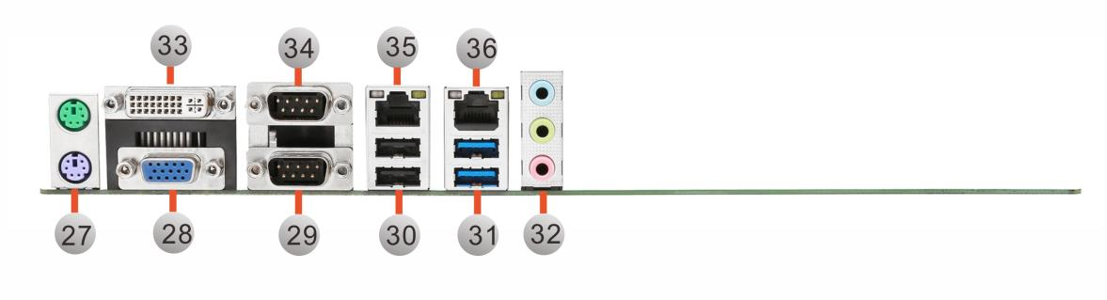



**ATX Mother Board**

|  |  |  |  |  |  |
| --- | --- | --- | --- | --- | --- |
| **Jumpers / Headers and Connectors** | | | | | |
| **1** | **Front USB Pin Header** | **P8** | **19** | **DIMM Slots** |  |
| **2** | **Parallel Pin Header** | **P8** | **20** | **CPU Slot** |  |
| **3** | **RS485/232 Select Jumper** | **P9** | **21** | **ATX1 Power Input Connector** |  |
| **4** | **COM3-6 Control Jumpers** | **P9** | **22** | **Mini-PCIE Slot** |  |
| **5** | **GPIO Pin Header** | **P10** | **23** | **PCIE X 16 Slot** |  |
| **6** | **COM3-6 Pin Header** | **P10** | **24** | **DIMM Slots** |  |
| **7** | **Front Panel Pin Header** | **P11** | **25** | **CPU Slot** |  |
| **8** | **Debug Pin Header** |  | **26** | **PCI Slots** |  |
| **9** | **COMS Clear Jumper** | **P11** | **27** | **PS/2 Connector** |  |
| **10** | **Debug Jumper** |  | **28** | **VGA Connector** |  |
| **11** | **System Fan Connectors** | **P11** | **29** | **COM2 Connector** |  |
| **12** | **CPU Fan Connector Front** | **P12** | **30** | **USB 2.0 Connectors** |  |
| **13** | **Keyboard and Mouse Pin Header** | **P12** | **31** | **USB 3.0 Connectors** |  |
| **14** | **COM1-2 Control Jumpers** | **P12** | **32** | **Audio Connector** |  |
| **15** | **Audio Pin Header** | **P12** | **33** | **DVI Connector** |  |
| **16** | **SATA3.0 Connector** |  | **34** | **COM1 Connector** |  |
| **17** | **SATA2.0 Connector** |  | **35** | **LAN Connector** |  |
| **18** | **ATX2 Power Input Connector** |  | **36** | **LAN Connector** |  |



**ATX Mother Board**

**5.Definition of Jumpers / Headers and Connectors**

**1)Front USB Pin Headers (5*2 Pin 2.54mm)**

|  |  |  |  |  |  |
| --- | --- | --- | --- | --- | --- |
| **Location** | **Header** | **Pin** | **Definition** | **Pin** | **Definition** |
|  | **F-USB1** | **1** | **+ 5V** | **2** | **+5V** |
| **3** | **USB1-** | **4** | **USB2-** |
| **5** | **USB1+** | **6** | **USB2+** |
| **7** | **GND** | **8** | **GND** |
|  |  | **10** | **NC** |
| **F-USB2** | **1** | **+ 5V** | **2** | **+5V** |
| **3** | **USB3-** | **4** | **USB4-** |
| **5** | **USB3+** | **6** | **USB4+** |
| **7** | **GND** | **8** | **GND** |
|  |  | **10** | **NC** |
| **F-USB3** | **1** | **+ 5V** | **2** | **+5V** |
| **3** | **USB7- [1]** | **4** | **USB6-** |
| **5** | **USB5+ [1]** | **6** | **USB6+** |
| **7** | **GND** | **8** | **GND** |
|  |  | **10** | **NC** |
| **F-USB4** | **1** | **+ 5V** | **2** | **+5V** |
| **3** | **USB7- [2]** | **4** | **USB8- [2]** |
| **5** | **USB7+ [2]** | **6** | **USB8+ [2]** |
| **7** | **GND** | **8** | **GND** |
|  |  | **10** | **NC** |

**Noties:**

**[1]: When Mini-PCIE Slot supports 3G devices, one of the USB ports of F-USB3 will be invalid.**

**[2]: F-USB4 can be accessed when mounting B85 chipset.**



**ATX Mother Board**

**2)Parallel Pin Header (13*2 Pin 2.54mm)**

|  |  |  |  |  |  |
| --- | --- | --- | --- | --- | --- |
| **Location** | **Header** | **Pin** | **Definition** | **Pin** | **Definition** |
|  | **LPT1** | **1** | **STROBE#** | **2** | **AUTOFEED#** |
| **3** | **DATA0** | **4** | **ERROR#** |
| **5** | **DATA1** | **6** | **INIT#** |
| **7** | **DATA2** | **8** | **SLCTIN#** |
| **9** | **DATA3** | **10** | **GND** |
| **11** | **DATA4** | **12** | **GND** |
| **13** | **DATA5** | **14** | **GND** |
| **15** | **DATA6** | **16** | **GND** |
| **17** | **DATA7** | **18** | **GND** |
| **19** | **ACKNLG#** | **20** | **GND** |
| **21** | **BUSY** | **22** | **GND** |
| **23** | **PE** | **24** | **GND** |
| **25** | **SLCT** | **26** | **N/C** |

**3)RS485/RS232 Select Jumper (3*2 Pin 2.54mm)**

|  |  |  |  |
| --- | --- | --- | --- |
| **Location** | **Header** | **Settings** | **Function** |
|  | **JCOM3-485** | **1-3、2-4(Default)** | **RS232** |
| **3-5、4-6** | **RS485** |

**ATX Mother Board**



**4)COM3-6 Control Jumper (6*2 Pin 2.54mm)**

|  |  |  |  |  |
| --- | --- | --- | --- | --- |
| **Location** | **Jumper** | **COM** | **Setting** | **Function** |
|  | **JCOM3-6-P1** | **COM3** | **1-3 [1]** | **Pin1: DCD** |
| **3-5** | **Pin1: + 5V** |
| **COM4** | **2-4 (Default)** | **Pin1: DCD** |
| **4-6** | **Pin1: + 5V** |
| **COM5** | **7-9 (Default)** | **Pin1: DCD** |
| **9-11** | **Pin1: + 5V** |
| **COM6** | **8-10 (Default)** | **Pin1: DCD** |
| **10-12** | **Pin1: + 5V** |

**Noties:**

**[1]: Jumper 1-3 isn’t on by default.**

**5)GPIO Header （6*2 Pin 2.00mm)**

|  |  |  |  |  |  |
| --- | --- | --- | --- | --- | --- |
| **Location** | **Jumper** | **Pin** | **Definition** | **Pin** | **Definition** |
|  | **J-GPIO1** | **1** | **PCH-GPO68**  **（0x1C48, bit 4）** | **2** | **PCH-GPI69**  **（0x1C48, bit 5）** |
| **3** | **PCH-GPO70**  **（0x1C48, bit 6）** | **4** | **PCH-GPI71**  **（0x1C48, bit 7）** |
| **5** | **GND** | **6** | **PCH-GPI1**  **（0x1C0C, bit 1）** |
| **7** | **PCH-GPO6**  **（0x1C0C, bit 6）** | **8** | **PCH-GPI7**  **（0x1C0C, bit 7）** |
| **9** | **PCH-GPO17**  **（0x1C0E,bit 1）** | **10** | **+ 5V [1]** |
|  |  | **12** | **NC** |

**Noties: All GPIOs can be programmed to input or output.**

**[1]: GPIO output is 5V signaling by default, 3.3V is available if specified (resistor selectable).**



**ATX Mother Board**

**6)COM3-6 Pin Headers (5*2 Pin 2.54mm)**

|  |  |  |  |  |  |
| --- | --- | --- | --- | --- | --- |
| **Location** | **Jumper** | **Pin** | **Definition** | **Pin** | **Definition** |
|  | **J-COM3** | **1** | **RS232: DCD3 [1]**  **RS485: DATA-** | **2** | **RS232: DSR3**  **RS485: N/C** |
| **3** | **RS232: RXD3**  **RS485: DATA+** | **4** | **RS232: RTS3**  **RS485: N/C** |
| **5** | **RS232: TXD3**  **RS485: N/C** | **6** | **RS232: CTS3**  **RS485: N/C** |
| **7** | **RS232: DTR3**  **RS485: N/C** | **8** | **RS232: RI3**  **RS485: N/C** |
| **9** | **GND** |  |  |
| **J-COM4** | **1** | **DCD4\*** | **2** | **DSR4** |
| **3** | **RXD4** | **4** | **RTS4** |
| **5** | **TXD4** | **6** | **CTS4** |
| **7** | **DTR4** | **8** | **RI4** |
| **9** | **GND** |  |  |
| **J-COM5** | **1** | **DCD5\*** | **2** | **DSR5** |
| **3** | **RXD5** | **4** | **RTS5** |
| **5** | **TXD5** | **6** | **CTS5** |
| **7** | **DTR5** | **8** | **RI5** |
| **9** | **GND** |  |  |
| **J-COM6** | **1** | **DCD6\*** | **2** | **DSR6** |
| **3** | **RXD6** | **4** | **RTS6** |
| **5** | **TXD6** | **6** | **CTS6** |
| **7** | **DTR6** | **8** | **RI6** |
| **9** | **GND** |  |  |

**Noties:**

**\* These signals are depending on relevant Jumpers (e.g. Pin1 of J_COM4 depends on**

**JCOM3-6_P1 Jumper), to find more details, check the above table (Location 4).**

**ATX Mother Board**



**[1]: This signal is RS232 by default. It also can be other signal via JCOM3-6_P1 and**

**JCOM3_485(Location 4 and Location 3).**

**7)Front Panel Pin Header (5*2 Pin 2.54mm)**

|  |  |  |  |  |  |
| --- | --- | --- | --- | --- | --- |
| **Location** | **Jumper** | **Pin** | **Definition** | **Pin** | **Definition** |
|  | **F-PANEL1** | **1** | **HD LED+** | **2** | **Power LED+** |
| **3** | **HD LED-** | **4** | **Power LED-** |
| **5** | **RESET-** | **6** | **PWR+** |
| **7** | **RESET+** | **8** | **PWR -** |
| **9** | **N/C** | **10** |  |

**9)COMS Clear Jumper (3*1 Pin 2.54mm）**

|  |  |  |  |
| --- | --- | --- | --- |
| **Location** | **Header** | **Settings** | **Function** |
|  | **JCOM3-485** | **1-3、2-4(Default)** | **RS232** |
| **3-5、4-6** | **RS485** |

**11）System and Auxiliary Fan Connectors (4*1 Pin 2.54mm)**

|  |  |  |  |  |  |
| --- | --- | --- | --- | --- | --- |
| **Location** | **Connector** | **Pin** | **Definition** | **Pin** | **Definition** |
|  | **SYS-FAN1** | **1** | **GND** | **2** | **+12V** |
| **3** | **FAN Speed Detection** |  |  |
| **SYS-FAN2** | **1** | **GND** | **2** | **+12V** |
| **3** | **FAN Speed Detection** |  |  |



**ATX Mother Board**

1. **CPU Fan Connector (4*1 Pin 2.54mm)**

|  |  |  |  |  |  |
| --- | --- | --- | --- | --- | --- |
| **Location** | **Connector** | **Pin** | **Definition** | **Pin** | **Definition** |
|  | **CPU-FAN1** | **1** | **GND** | **2** | **+12V** |
| **3** | **FAN Speed Detection** | **4** | **FAN Speed Control** |

1. **Keyboard and Mouse Pin Header (6*1 Pin 2.00mm)**

|  |  |  |  |  |  |
| --- | --- | --- | --- | --- | --- |
| **Location** | **Header** | **Pin** | **Definition** | **Pin** | **Definition** |
|  | **J-KBMS1** | **1** | **KB-CLK** | **2** | **KB-DATA** |
| **3** | **MS-CLK** | **4** | **GND** |
| **5** | **+ 5V** | **6** | **MS-DATA** |

1. **COM1-2 Control Jumpers (3*2 Pin 2.00mm)**

|  |  |  |  |
| --- | --- | --- | --- |
| **Location** | **Jumper** | **Settings** | **Function** |
|  | **JCOM1-2-P1** | **1-3、2-4(Default)** | **Pin1: DCD** |
| **3-5、4-6** | **Pin1: + 5V** |

1. **Front Audio Pin Header (5*2 Pin 2.54mm)**

|  |  |  |  |  |  |
| --- | --- | --- | --- | --- | --- |
| **Location** | **Header** | **Pin** | **Definition** | **Pin** | **Definition** |
|  | **F-AUDIO1** | **1** | **FP-MIC-L** | **2** | **GND** |
| **3** | **FP-MIC-R** | **4** | **+ 3.3V** |
| **5** | **FP-OUT-R** | **6** | **SENSE1_RETURN** |
| **7** | **GND** | **8** |  |
| **9** | **FP-OUT-L** | **10** | **SENSE2-RETURN** |

**[END]**